Level-6

Final Project

Student Management

By

Jugraj Singh

Table of Contents

Project Proposal 3

Goals and Objectives 3

Project Scope 4

Project Deliverables 4

Project Specifications 4

Target Audience 4

Project Tasks and Milestones 4

Resource Requirements 6

Project Risks 6

Software Project Report 8

Analysis 8

Requirements Analysis 8

Detail Design 9

Home Page 9

Registration Page 9

Login Page 9

User Product Detail Page 9

Admin Registration Page 9

Project Testing 10

System Usability Testing 10

Testing 10

User Manual 12

Quick Setup Guide 12

User Setup 12

Admin Setup 12

General Information 12

System Overview 12

System Summary 12

System Configuration 12

User Access Levels 12

# Project Proposal

## Goals and Objectives

The goal of this project is to implement a student management system. In this application, there are two user’s admin and student. Admin has the authority to add new student, course and enrolment. He can register students, add, update and delete the information of the students. Admin can assign new courses to students, can update and delete the course. Also, able to manage the enrolments of the students in terms of adding, updating and deleting. Student cannot register themselves, they can only view their information and can update their details.

## Project Scope

This is a 20 days project in which I have implemented a student management system application. The scope of this project is to register new students, manage courses and enrolment of the students. Students can only view their details and can edit the details. They cannot register themselves.

## Project Deliverables

This project will require certain deliverables. The table below outlines these deliverables.

|  |  |
| --- | --- |
| **Deliverable** | **Description** |
| **Final Report** | This document presents the plan and defines the information and specifications. The milestone schedule, software, hardware and other important details are also mentioned. |
| **Executable Programme** | Executable code of the project. |
| **User Documentation** | This will demonstrate how one can use the web application |
| **Test Plan** | This will provide the test detail of the project |

## Project Specifications

* Login and registration of student by admin
* Add, update and delete of student registration by the admin
* Admin can add, edit and update courses for students.
* Admin can add, update and delete the enrolments of the students.
* student can only view their details in the system. They cannot register, They can edit their personal detail only.

## Target Audience

* Students who are keen to study courses of their choice aged group- 16 to 100 pus.

## Project Tasks and Milestones

The table below shows the Project Tasks and Milestones

|  |  |  |  |  |  |  |  |  |  |  |  |  |  |  |  |
| --- | --- | --- | --- | --- | --- | --- | --- | --- | --- | --- | --- | --- | --- | --- | --- |
| **Stages** | **Activities** | **Week1-2** | | | | **Week-2-3** | | | | | **Week-3-4** | | | | |
| Planning | **Research and brainstorming around technology** |  |  |  |  |  |  |  |  |  |  |  |  |  |  |
| **First Meeting** |  |  |  |  |  |  |  |  |  |  |  |  |  |  |
| **Project Proposal** |  |  |  |  |  |  |  |  |  |  |  |  |  |  |
| **Proposal Documentation** |  |  |  |  |  |  |  |  |  |  |  |  |  |  |
| Implementation | **Design of the database** |  |  |  |  |  |  |  |  |  |  |  |  |  |  |
| **UI Design** |  |  |  |  |  |  |  |  |  |  |  |  |  |  |
| **Identity Framework Implementation** |  |  |  |  |  |  |  |  |  |  |  |  |  |  |
| **UI Implementation** |  |  |  |  |  |  |  |  |  |  |  |  |  |  |
| **Admin Interface Implementation** |  |  |  |  |  |  |  |  |  |  |  |  |  |  |
| **Student interface Implementation** |  |  |  |  |  |  |  |  |  |  |  |  |  |  |
| **Testing** |  |  |  |  |  |  |  |  |  |  |  |  |  |  |
| Closing | **Final Documentation** |  |  |  |  |  |  |  |  |  |  |  |  |  |  |

## Resource Requirements

Following technologies and development method:

* Windows Operating System
* 64-bit Processor and 8 GB or more RAM
* Asp.net MVC Framework
* Identity framework- ASP

## Project Risks

Below are the high-level risks identified that could affect project completion and success:

* Delays in projects can cause a chain delay in other related tasks.
* The size and length of the project may be underestimated.
* Exceptional application protection must be given for the project with confidential information.
* The total needed functionalities can outweigh what the programmer can provide in the time available.

|  | **Low (Yes)** | | | | **RISK** | | | | **(No) High** | | | |
| --- | --- | --- | --- | --- | --- | --- | --- | --- | --- | --- | --- | --- |
| 0 | 1 | 2 | 3 | | 4 | 5 | 6 | | 7 | 8 | 9 |
| **Inherent Risks** |  |  |  |  | |  |  |  | |  |  |  |
| **Project Objectives** |  |  |  |  | |  |  |  | |  |  |  |
| Is the project minor? |  |  |  |  | |  |  |  | |  |  |  |
| Is the project of less important to the business? |  |  |  |  | |  |  |  | |  |  |  |
| Is the project functionally upfront? |  |  |  |  | |  |  |  | |  |  |  |
| Can multiple parties identify the criteria? |  |  |  |  | |  |  |  | |  |  |  |
| Is the subject area well documented? |  |  |  |  | |  |  |  | |  |  |  |
| Are previous projects well documented? |  |  |  |  | |  |  |  | |  |  |  |
| **User Organisation** |  |  |  |  | |  |  |  | |  |  |  |
| Does the project keep current client procedures? |  |  |  |  | |  |  |  | |  |  |  |
| Is there any other organisational change during the project unlikely? |  |  |  |  | |  |  |  | |  |  |  |
| Are the users gathered in one place? |  |  |  |  | |  |  |  | |  |  |  |
| **Technology** |  |  |  |  | |  |  |  | |  |  |  |
| Is hardware being used? |  |  |  |  | |  |  |  | |  |  |  |
| Can programming be avoided? |  |  |  |  | |  |  |  | |  |  |  |
| Is the project technically upfront? |  |  |  |  | |  |  |  | |  |  |  |
| Is the quality of existing data good? |  |  |  |  | |  |  |  | |  |  |  |
| **Acquired Risks** |  |  |  |  | |  |  |  | |  |  |  |
| **Scope and Goal** |  |  |  |  | |  |  |  | |  |  |  |
| Is the project scope well defined and agreed? |  |  |  |  | |  |  |  | |  |  |  |
| Is the project goal well defined and agreed? |  |  |  |  | |  |  |  | |  |  |  |
| **Project Organisation** |  |  |  |  | |  |  |  | |  |  |  |
| Are users committed to the project? |  |  |  |  | |  |  |  | |  |  |  |
| Are the skills needed available? |  |  |  |  | |  |  |  | |  |  |  |
| Is there a backup for all team members? |  |  |  |  | |  |  |  | |  |  |  |
| Is the project third-party independent? |  |  |  |  | |  |  |  | |  |  |  |
| Is a small group able to achieve design? |  |  |  |  | |  |  |  | |  |  |  |
| **Experience, Training and Support** |  |  |  |  | |  |  |  | |  |  |  |
| Is the IT department aware of the technology? |  |  |  |  | |  |  |  | |  |  |  |
| Is the software common to users? |  |  |  |  | |  |  |  | |  |  |  |
| Does the software have good support? |  |  |  |  | |  |  |  | |  |  |  |

# Software Project Report

## Analysis

### Requirements Analysis

#### The specification review includes the system's functional and non-functional aspects.

#### Functional

The functional requirements of this project are divided into types. One for Admin, and one for student.

|  |  |
| --- | --- |
| **Users** | **Functional Requirements** |
| **Admin** | * Login/logout * Manage student registration. * Add, delete, edit students/registrations. * Add, edit and delete courses. * Add, edit and delete enrolments |
| **Student** | * Login/logout * Can view their details and edit their details. |

#### Non-Functional

|  |  |
| --- | --- |
| **Operational** | * The system should able to run on all web browsers. * The system should be accessible via mobiles and other devices. |
| **Performance** | * The system should have a 99% uptime |
| **Security** | * Only Admin have full access to the system * student can have access to their accounts only. |

## Detail Design

### Home Page

This is the main landing page of the application. On this page there are five button on the navigation page- home, students, register, login and register a course admin.



### Registration Page

With the help of this page admin can register a student on student management application. User needs to enter a valid email and password and need to confirm password and need to click on register.

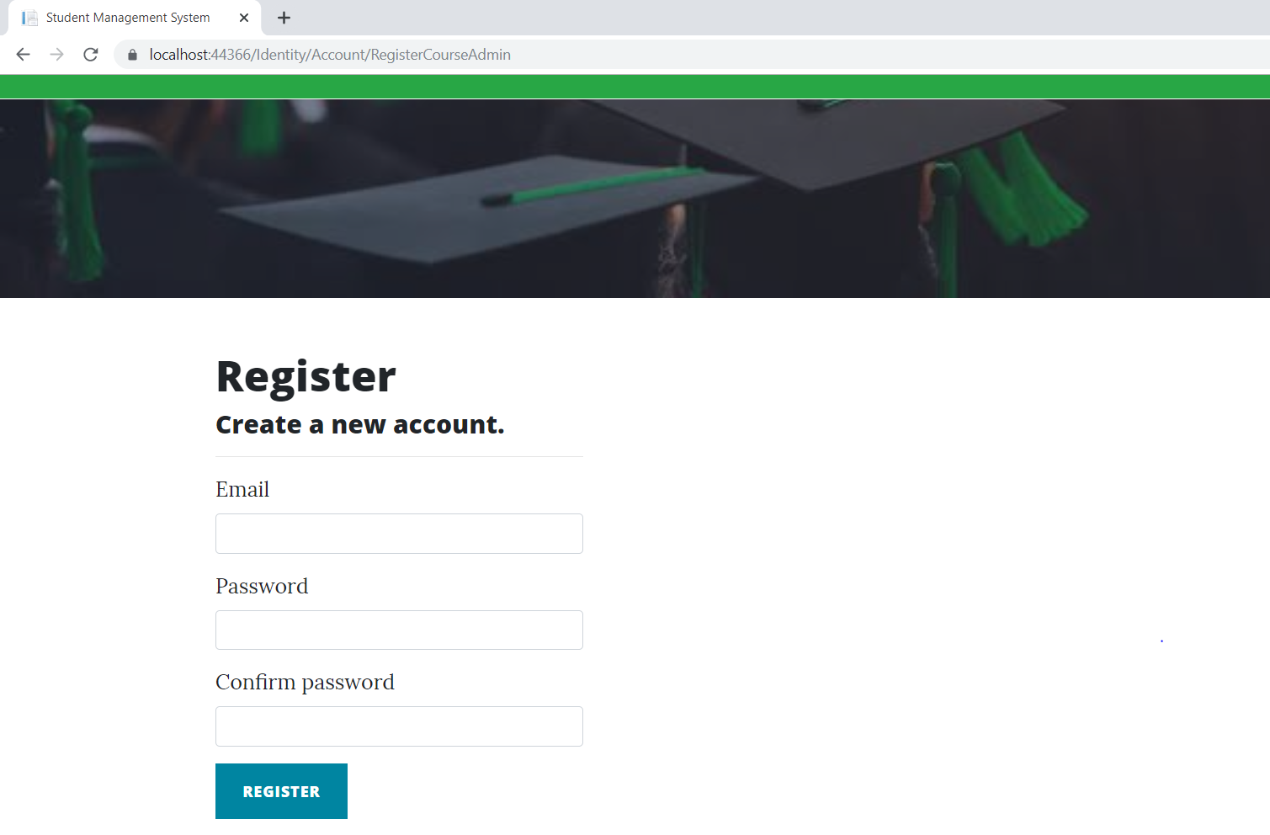

### Login Page

Once admin registers a student successfully with the student management application, he/she can login to the application as registered user and view his/her details.

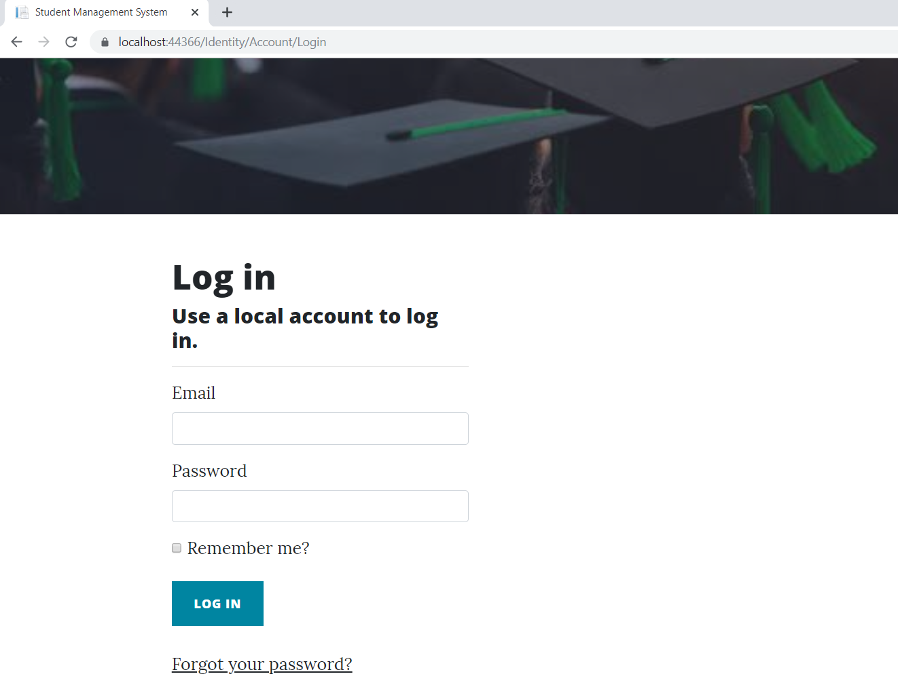

### Admin Student Page

With the help of this page, admin can edit, delete the details of the registered students as well as view their details.

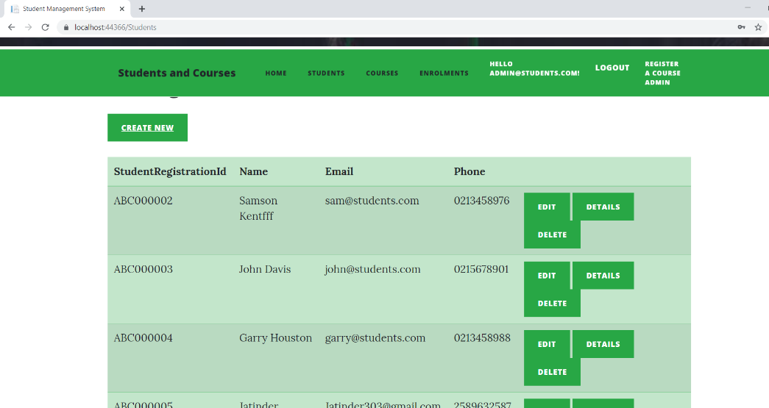

### Admin Enrolment Page

With the help of this page, admin can add enrolments of the students. It will reflect the start and end date of the enrolment for students who are registered. Moreover, admin can edit, delete enrolment s and can view the details of the enrolments.

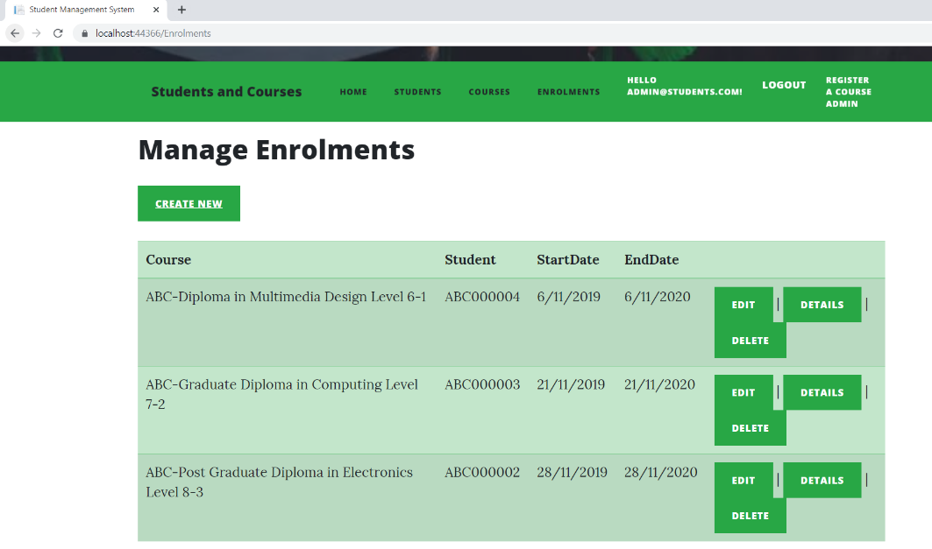

### Admin Course Page

This page will show the courses for students. Here admin can manage various courses for registered students. Admin can add the student to course, delete the course and also view the details of the particular course in which the student is enrolled.

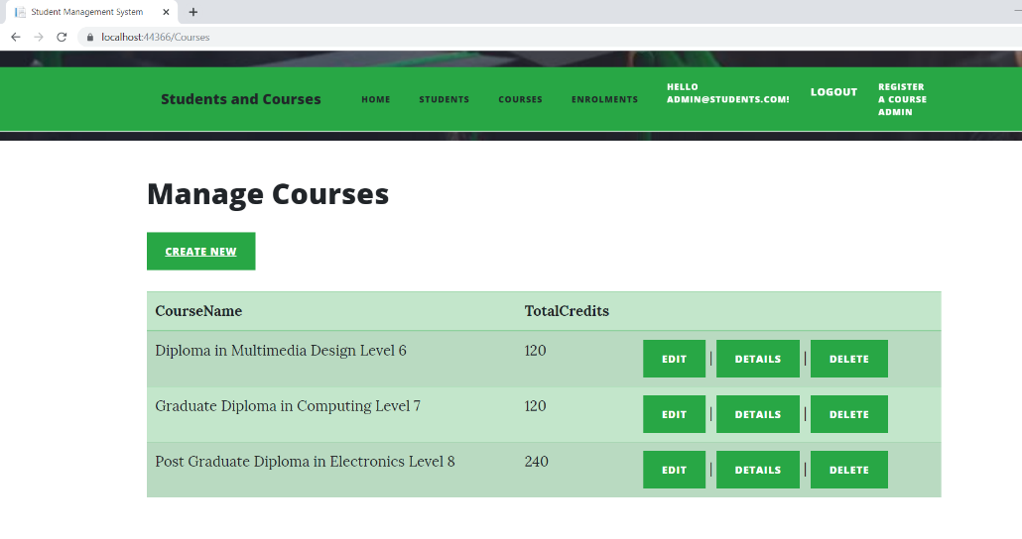

### Student Home Page

This page is for the registered students. When login to the system, registered students can view their details and can edit the details.

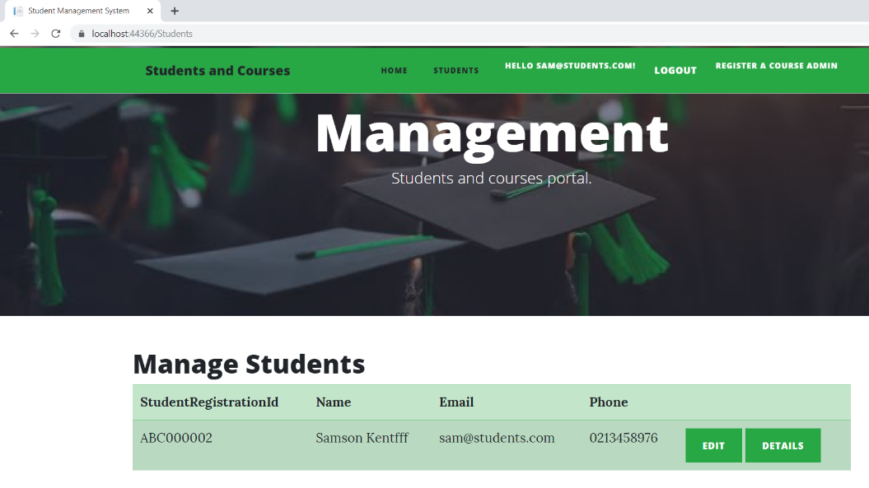

# 

# Project Testing

## System Usability Testing

### Testing

Answer Scale: 1- Strongly Agree, 2- Agree 3- Average, 4- Disagree, 5- Strongly Disagree

|  |  |  |
| --- | --- | --- |
| **Tester – 1** | | **Scale** |
| **No.** | **Question** | **1-5** |
| 1 | I think that I would like to use this application more frequently | 1 |
| 2 | I found the system complicated | 2 |
| 3 | Is system easy to use? | 1 |
| 4 | Do you think you need the support of a technical person to use this system? | 4 |
| 5 | All functions of the system were well integrated | 3 |
| 6 | Did you find any inconsistencies in this system | 5 |
| 7 | I think most people would learn to use this system very quickly | 1 |
| 8 | I found the system very challenging to use | 4 |
| 9 | I felt very confident using the system | 1 |
| 10 | I needed to learn a lot of things before using the system | 4 |

**Tester 1**

**Tester 2**

|  |  |  |
| --- | --- | --- |
| **Tester – 2** | | **Scale** |
| **No.** | **Question** | **1-5** |
| 1 | I think that I would like to use this application more frequently | 1 |
| 2 | I found the system complicated | 2 |
| 3 | Is system easy to use? | 1 |
| 4 | Do you think you need the support of a technical person to use this system? | 4 |
| 5 | All functions of the system were well integrated | 3 |
| 6 | Did you find any inconsistencies in this system? | 5 |
| 7 | I think most people would learn to use this system very quickly | 1 |
| 8 | I found the system very challenging to use | 4 |
| 9 | I felt very confident using the system | 1 |
| 10 | I needed to learn a lot of things before using the system | 4 |

**Tester -3**

|  |  |  |
| --- | --- | --- |
| **Tester – 3** | | **Scale** |
| **No.** | **Question** | **1-5** |
| 1 | I think that I would like to use this application more frequently | 1 |
| 2 | I found the system complicated | 2 |
| 3 | Is system easy to use? | 1 |
| 4 | Do you think you need the support of a technical person to use this system? | 4 |
| 5 | All functions of the system were well integrated | 3 |
| 6 | Did you find any inconsistencies in this system | 5 |
| 7 | I think most people would learn to use this system very quickly | 1 |
| 8 | I found the system very challenging to use | 4 |
| 9 | I felt very confident using the system | 1 |
| 10 | I needed to learn a lot of things before using the system | 4 |

# User Manual

## Quick Setup Guide

### User Setup

#### As a web application there is no need for a separate configuration for the intended clients, but registrations are available through the website to access its functionality. The web application can be accessed through local hosting.

### Admin Setup

#### Admin needs to login using the valid credentials.

#### Admin is responsible for managing student, courses and enrolments.

## General Information

### System Overview

Student management system is an online app. In this application, there are two user’s admin and student. Admin has the authority to add new student, course and enrolment. He can register students, add, update and delete the information of the students. Admin can assign new courses to students, can update and delete the course. Also, able to manage the enrolments of the students in terms of adding, updating and deleting. Student cannot register themselves, they can only view their information and can update their details.

## System Summary

### System Configuration

Student Management System is a web application developed using Asp.net MVC Framework. It operates on most modern web browsers and requires no special programme configuration. As a web application, internet access is needed.

### User Access Levels

Only registered students can access the features of Student Management System

* **Admin:** Full access to the system and all functionalities. Full access to all course and registered student and enrolment details.
* **Students:** Limited access to the app. Can only see their accounts and edit their details.